**Blossburg V.I.B.E.’s 2016**

**HOT DOG EATING CONTEST**

**Dogs and buns provided by - Bloss Holiday Market**

Sunday, October 9th · 2:00pm

Blossburg VIBE Fall Festival

READ CAREFULLY THE OFFICIAL CONTEST RULES AND ENTRY FORM FOR THE BLOSSBURG VIBE 2016 HOT DOG EATING CONTEST. Complete and sign this document below.

**CONTEST RULES:** There will be one competition for all qualifying contestants. Contestants will compete with each other for a Grand Prize of $200. Competitors will compete on Sunday October 9, 2016 at 2:00 pm at the Fall Festival downtown Blossburg. Contestant must be present and registered at the registration table by 1:30pm on Sunday, October 9, 2016 and pay a $10.00 entry fee for final instructions. A contestant will forfeit his or her place should he or she fail to register at the registration table by 1:30pm on Sunday, October 9, 2016 and be present at 2:00 pm at the registration table for the contest. All contestants must be 16 years of age and older.

The object is to eat as many hot dogs as possible within the allotted time of 10 minutes. Contestants may eat either sitting or standing in their designated area. Contestants will be allowed to use and/or drink only the water provided during the competition. Condiments are allowed. Contestants must wait for the starting signal to begin eating and may not touch any hot dogs prior to the starting signal. Contestants must stop eating and must promptly place their hands down on the table or at their side at the ending signal. Contestants may not put additional hot dogs in their mouths after the ending signal, but will be allowed 15 seconds to swallow any hot dogs already in mouth. If a contestant throws up or regurgitates, he or she will automatically be disqualified. Judges will be on hand to assure adherence to contest rules. In case of a tie, the contestants will have an eat -off. The first person to finish the most hot dogs in five minutes will be the winner.

**PRIZE AWARDS:**

Prizes will be awarded as follows:

**Contestant who eats the most hot dogs within the allotted time of 10 minutes will receive the Grand Prize of $200 prize money, a trophy, and the honor of being Blossburg’s Top Dog.** **All qualified participating contestants will receive a hot dog eating contest t-shirt.**

**ACKNOWLEDGEMENT OF RISKS AND WAIVER OF LIABILITY:** Contestant acknowledges that there are risks of personal injury, illness and possible loss of life, and risks of damage to or loss of personal property, which may result from participating in this contest. Contestant voluntarily enters Blossburg Vibe’s Hot Dog Eating Contest and assumes all of these risks. Contestant, as a condition of entry, agrees to indemnify, defend and hold harmless Blossburg Vibe and affiliated companies, their vendors, their advertising, promotion and public relations agencies, co-sponsoring companies and their affiliates and agencies, and all officers, directors, employees and agents of the aforesaid entities, from any and all claims and costs, including attorneys’ fees, relating to, arising from or in connection with participation in this contest or the receipt or use of any prize. In so doing, contestant releases and indemnifies the aforesaid entities and individuals from liability for injuries or damages of any kind arising from or in connection with participation in this contest or the receipt or use of any prize. In no event shall Blossburg Vibe or Blossburg Borough be liable to a contestant for acts or omissions arising out of or related to the contest or that contestant’s participation in the contest.

**Blossburg V.I.B.E.’s 2016**

**HOT DOG EATING CONTEST**

**Dogs and buns provided by - Bloss Holiday Market**

Sunday, October 9th · 2:00pm

Blossburg VIBE Fall Festival

This form is necessary for any contestant of the Blossburg Vibe Hot Dog Eating Contest.

Please complete this form. You will not be allowed to participate without this signed form.

Name of contestant: ___________________________________

Date of Birth: ____________ T-shirt Size: ________________

Is there a nickname you would like to be called during the contest?

(ex. John “the bottomless pit” Smith) ______________________

_____________________________________________________

Home address: ________________________________________

_________________________________________

Phone: _______________________ Cell:___________________

Emergency Contact Name: ______________________________

Phone: ______________________ Cell: __________________

_________________________________ ____________

Contestant Signature Date

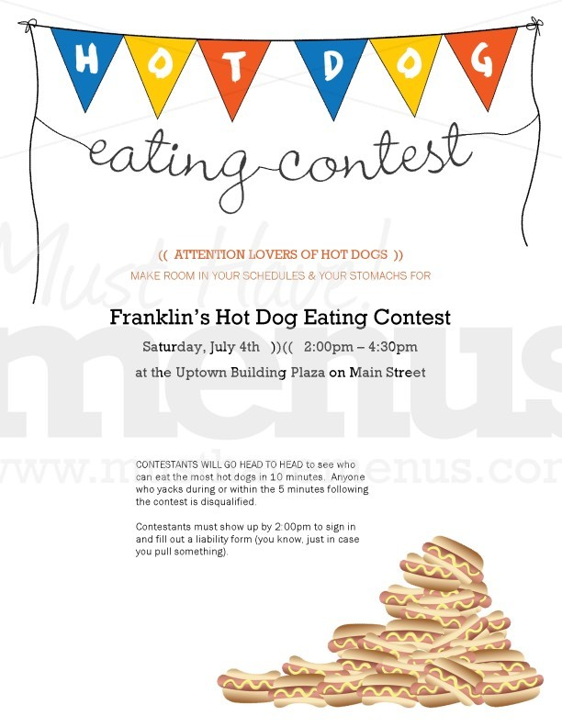

_________________________________ ____________

Parent Signature Date

(Required for participants under age 18)